CRM Project

Functional Specification - Enhancement

PP6

(PP6) CM-090-090-070-E CM_ENH_450 Contract Mgt New Contract & Meter Data

Deliverable Name | (PP6) CM-090-090-070-E CM_ENH_450 Contract Mgt Contract & Meter Data
Date | 11/1/2010
Revision | V1.0
Signed off By | Functional lead/PP6 Owner
Signoff Date

TABLE OF CONTENTS

1. Version 3
2. Approvals 3
3. Priority Mention the Priority of the object from the FRICEW list in ILM. Processing Mode (check all that apply) 3
Low Medium High 4
4. Enhancement Requirements Description 4
5. Impacted Systems 4
6. Approach to be followed < List the type of enhancement whether it is a user exit, BADI or Custom transaction> 4
7. Roles and Volumes 4
8. Security & Control Requirements 5
8.1. Security Requirements 5
8.2. Control/Audit Requirements 5
9. Dependencies 6
9.1. Development Dependencies 6
9.2. Run/Execution Dependencies 6
9.3. Archiving Dependencies 6
10. Execution Steps 6
10.1. Process Description 6
10.2. Process Flow 7
10.3. As-Is Systems Referred To 7
10.4. Processing Options 7
11. Enhancement Description 8
11.1. Detailed Description of the Enhancement 8
11.1.1. Product Questionnaire 8
11.1.2. Contract & Meter Details 16
11.2. UI Design and Screen Flow < Mention the WEBUI Design in the sense the mock up screens and the navigation flow between the screens etc> 21
11.3. Access Method or Path for Enhancement 22
11.4. Required Custom Tables (if known) 22
11.5. Error Handling Rules 23
12. Enhancement Reconciliation & Testing Requirements 24
12.1. Data Validation 24
12.2. Testing Reconciliation 24
12.3. Performance Issues 24
13. Additional Information 24
14. Open Items 24
15. Functional Unit Test cases <Here they should list the possible test scenarios in the table below> 24

Version
Ensure that any approved change requests that affect scope are documented in the revision history and include CR #.
Version | Change Description | Author | Date Released | Sections Impacted
Enter in the version number | Brief description of the change | Who made the change | Date change was made | Mention the sections impacted with this change
1.0 | Creation | J Jarone
1.1 | Pre Owner Review | J Jarone | 11/17/2010
1.2 | Post Owner Review | J Jarone | 11/17/2010
1.3 | Update Test Results | J Jarone | 12/21/2010
1.4 | Update Life Support logic | J Jarone | 1/21/2011
2.0 | Removed CRM Residential Heating Fuel update logic - Page 15  Cancel Process - Added popup Cancel Process message when notifications exist – Page 17  Removed Security Deposit waiver reason from Interaction Record. Clarified the waiver reason should be used when creating the ECC movein document – Page 19 | J Jarone | 2/15/2011 | 11.1.  11.2..1.1  11.1.2.1.5
3.0 | Change Request: CHG04166  Updated 11.1.2.2 Page 21 Meter Read Date  Change Request: CHG4160  Updated 11.1.2.2 Page 22  Remove Meter Read Release  Change Request: CHG04060  Updated 11.1.1.2.2 Page 12, Gas a default entry for Home Heating Fuel Type  Updated 11.1.2.1 Page 17 Remove hyperlinks for Contract Details  Updated 11.1.2.1.4 Security Deposit Reason and 11.1.2.1.5 Waiver on Page 20 | Sanjeev Singh | 08/02/2011 | 11.1
4.0 | Clarify LifeSupp Operand updates | Judy Jarone | 02/02/2012 | 11.1.1.3 – Page 16

Approvals
The individuals listed below will be required to review and approve this document.
Reviewers Title | Reviewer Role | Name
Project Title of Reviewer | Reviewer's Role (Responsible, Approve, Consult, Inform) | Reviewer's Name

Priority
Mention the Priority of the object from the FRICEW list in ILM.
Processing Mode (check all that apply)

Low Medium High

Enhancement Requirements Description
<This section should contain a detailed description of the business requirements for this enhancement in business terms. Please insert any description of the business flow which would aid in understanding this process.>
This enhancement is one of 7 sub process, 5 of which are to be developed within the New Contract process framework. The processes are as follows, Pre Move-In, Contract & Meter Data, Notifications, Address Maintenance, Summary, Ebill Presentment, and AllConnect – figure 4.1. This enhancement, Contract & Meter Data, will require input from the Pre Move-In development and will export information required in subsequent steps within the process framework.

Figure 4.1

Impacted Systems
<This list should include systems that are being impacted as a result of this enhancement.>
CRM 7.0 Web IC: CRM 7.0 Web Client Interaction Center Production System
ECC 6.0 / IS-U ECC 6.0 / IS-U: Back End Production System (Enterprise Central Component)

Approach to be followed
< List the type of enhancement whether it is a user exit, BADI or Custom transaction>
Custom Transaction

Roles and Volumes
<Describe information regarding users and volumes. Make sure to note if the use of this development will require additional communication and/or training. Also, specify what the volume requirements will be needed by the Go-Live date.

Complete the table below with the correct project-specific information for this functional specification. Instructions are in the middle row, and a sample entry is in the bottom row.>
Role | Estimated Volume Requirement | Comments
List name of role; should come from the list of security roles | Enter the estimated volume requirements that will be needed by the Go-Live date | Enter other comments including if this development will require additional communication and/or training
CSR 2, 3, 4, VCC MGMT | 1,000,000 / Year
BCOS | +- 75 / Day
Billing | +- 75
Consumer Affairs | +- 75
Revenue Recovery | +- 75

Security & Control Requirements

Security Requirements
<Describe any security requirements that need to be put in place as a result of this development object. This could include security access to affected transactions or new transactions that may result from this development. If the enhancement has to be archive enabled, list additional security to be added to the roles.>

Figure 8.1.1

Security requirements will be handled through business roles. The business roles in figure 8.1.1 will have access to the New Contract process framework.

- CM-090-090-15-S Security will be handled through business Roles. We are limiting the Contract Management Work Center by business role.

Control/Audit Requirements
<Describe any control requirements that need to be put in place as a result of this development object>.
- If applicable, please answer the question and also provide detail to the question.
- The questions listed below are not all inclusive to the control requirement that may be required. If there are any other controls requirements please document them as well.

- Indicate if this enhancement is being developed to address a control requirement?
- Financial/SOX Impact - Does the enhancement have any impact to financial reporting? If yes, is the amount significant (i.e. greater than $35 million annually)? Please provide an estimate. Yes, a security deposit or Seasonal Connection Fee may be required. This enhancement will enable the security document request and connection fee creation and capture waiver reason if declined.
- Regulatory Impact - Does the enhancement have any impact to regulatory compliance (i.e. FERC, NERC, etc)? If yes, please provide a reference to the rule and describe the impact. No
- Operational Impact - Is the enhancement relied upon for a mission critical process or providing services to customers? If yes, please identify the mission critical process and describe how this enhancement is used in the context of this process. Yes, this enhancement provides the ability to enter the New Contract Start date, apply meter reads and capture security deposit and seasonal connection fee requirements.

Dependencies

Development Dependencies
<List the configuration, development, and other work that must be considered during the creation of this enhancement.>

Seq. | Development ID | Change ID | Description
1 | CM_ENH_110 | CM-090-090-050-E | FO_ENH_670_1_Move In_PMI - Contract Mgt Pre-Move In
2 | CM_ENH_1770 | CM-050-70-030-E | (PP6) CM-050-70-030-E Enter Meter Read & Perform Corrections

Run/Execution Dependencies
<Once in production, this development object may need to be executed before or after another system event. List other system events that this development object should follow or precede. If the enhancement is to be archived enabled, does it need to have adequate archived sessions, info structures, etc established in order to test/execute.>

Run/execution dependencies exist within the process framework as described in figure 4.1. Enhancement CM-090-090-070-E Contract Mgt Pre-Move In view must be executed prior to the Contract & Meter Data process step.

Archiving Dependencies
<List how the changes would impact archiving, if the enhancement impacts existing archived objects (i.e. table structures). Also list what needs to be regression tested from an archiving perspective.>

N/A

Execution Steps
This process may be accessed in two ways:
- A user may click directly on Contract Management Work Center
- A user may select the dropdown from Contract Management Work Center, and then select the sub menu New Contract (This will be the Best Practice method)
- User has accessed the Pre Move-In view within the process framework.

Process Description
<Explain the process for when this development object will be used. If this is tied back to a certain task within a process you may insert the Task Profile document here as well.

Enter any of the following information available:
- Transaction Code
- User Exits
- Performance Consideration
- Z Tables created
- Code reuse.
New Enhancement / ECC Code reuse

Process Flow
<Create a diagram that visually depicts the process.>
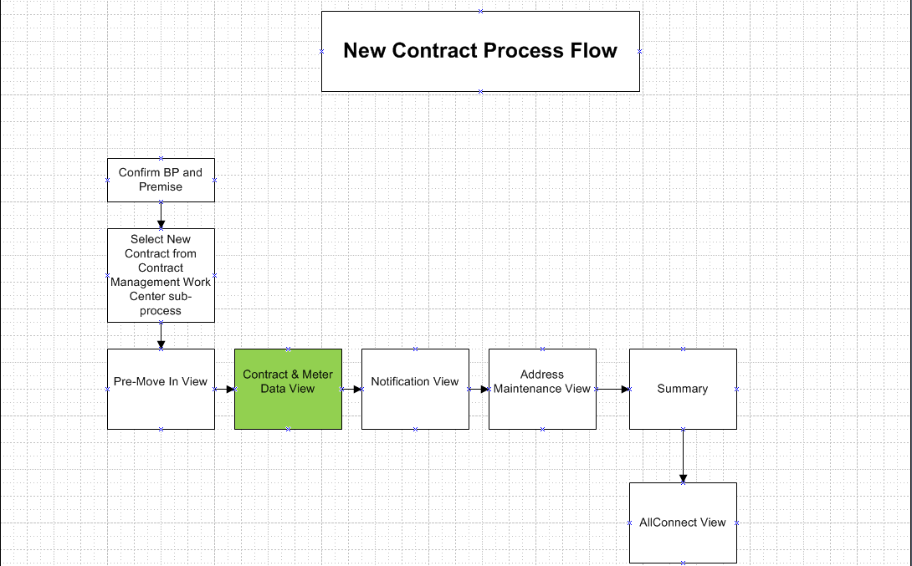

As-Is Systems Referred To
<List the systems that the task pertaining to this development object is performed in. If this is a new task (i.e. not being performed today), list it ‘Not applicable’.>

This task is currently performed in FO_ENH_670_1_Move In_PMI Screen and ECC Move-In FOP

Processing Options
<Indicate the Processing Mode, Frequency, and Lifetime of Development by selecting and placing an ‘X’ in the box next to the correct options below. Right click on the gray box, select properties, and specify “Checked”.>
Processing Mode (Select one of the following)
Batch Online – via Transaction Code Online – via Menu Path
On demand

Frequency (Select one of the following)
Daily
Weekly Quarterly
Monthly Annually
Other (If other, describe here) On Demand

Lifetime of Development (select one)
Permanent
Temporary, e.g. until rollouts are complete, specify details here

Enhancement Description
<Provide a brief description of the enhancement.>
The New Contact process framework has been broken into individual units of work that must share data when configured as a whole. This development will need access of the data as the result of the Pre-move-In enhancement and will export data to the Notification, Address Maintenance, and Summary developments.

This document will describe the enhancement in 3 sections. Section 1 will describe the production questionnaire enhancement, section 2 will describe the Contract section, and section 3 will describe the Meter section.

Detailed Description of the Enhancement
<Provide a written description of the functionality that needs to be developed. Identify/describe the SAP application transaction that uses or is used to invoke the enhancement. Describe tables, transactions, reports, forms, screens and other objects that need to be created or modified. Insert a Visio flow diagram of the process to be executed by the enhancement, and add any other information required to develop the enhancement.>

Developer has to look for BOL objects for the fields mentioned in this PP6. This PP6 gives the field/program details references to ECC.

This enhancement will require the program to retrieve and store the following information:

- Import –
  - Pre Move-In View FACTA validation result – The FACTA validation return code is used in the Security Deposit determination logic.
- Export –
  - Meter Readings Entered
  - New Contract Start Date
  - Security Deposit/Reason/Waiver
  - Seasonal Connection Fee Requested

Product Questionnaire
The product Questionnaire is used to derive the product and product attributes based on the answers provided by the user. The user must answer the questionnaire’s required fields and select the ‘Next’ button to continue the New Contract Process. The ‘Next’ button will move the user forward to the view shown in 11.1.2.

  - Billing Class The billing class is a field on the Product. It determines whether the premise is considered Residential or Commercial. The billing class is determined by getting the current contracts for the premise and selecting the first POD, sorted by division, associated with the premise. Using the POD, get the Billing Class from the product.
If ZISU_PROD-CLAS-ZZ0012 = ‘RES’ then the premise is residential. Otherwise, the premise is commercial.
  - Primary Premise – The premise is considered primary if the Electric ECC rate category rate fact exists with a value of FLG_PRIME and the Premise is Commercial.
    - Get the current ECC rate category for the electric installation from table EANLH where the system date is between the validity dates (AB, BIS) of the installation timeslice.
    - Using the rate category look in table ETTAF for the following operand values FLG_PRIME and string3 = X and the system date is between the validity dates (AB and BIS). If found then the premise is Primary
Existing code can be found in FOCS_MI_VERIFYF01 perform GET_RATE_BASED_INFO.

  - Multi Family Dwelling – If the product for the latest contract has a product contained in table ZTFO_RATECATCAT and has category of MULTDWELL it is considered a Multi Family Dwelling (residential multifamily) and will NOT be allowed to change during the New Contract Process The product questionnaire will still be mandatory since other updates may need to be made. The latest product should be display in the Contract Details section for the Multi Family Dwelling installation. Display System warning Message 010 in section 11.5.
  - TOU/TOD Dwelling - If the product for the latest contract has a product contained in table ZTFO_RATECATCAT and has category of TOU it is considered a TOD Dwelling (Time of Use/Time of Day) and will NOT be allowed to change during the New Contract Process. The product questionnaire will still be mandatory since other updates may need to be made. The TOU product should be displayed in the Contract Details section for the TOU installation. Display System warning Message 020 in section 11.5.
  - Business Partners Active Contracts – The product questionnaire will require the lookup of the Business Partners active contracts. The program will need to determine if active contract with product attributes of ‘FARM’, ‘SENIOR’, LIFESUPP, INCOME_ASC, and INCOME_AST exists.
The Active contract can be retrieved from the query: IsuOrderItemQuery
The BUPA_NUMBER will need be passed to base the search on business partner OR the PREMISE_NUMBER will need to be passed to base the search on the Premise.
On result of the query Check the field "ISURQCONTEND" = '00/00/0000' then that contract is active.
  - Business Partners Contracts – The product questionnaire will require the lookup of the Business Partners previous and active contracts. The program will need to determine if active contract with product attributes of ‘LIFESUPP exists or for any previous contracts ended within the last 12 months
The Active contract can be retrieved from the query: IsuOrderItemQuery
The BUPA_NUMBER will need be passed to base the search on business partner OR the PREMISE_NUMBER will need to be passed to base the search on the Premise.
On result of the query Check the field "ISURQCONTEND" = system date – 365 days then that contract is within the 12 month window.
On result of the query Check the field "ISURQCONTEND" = '00/00/0000' then that contract is active.
The product questionnaire will be interactive meaning depending on the user’s response different questions will be displayed. This section will be separated into residential primary, residential secondary and commercial question flows. Questions that are mandatory for the user to answer will be marked with a red asterisk.

      - Product Questionnaire
The product questionnaire usage answer begins when the user selects either Residential or Commercial. Base on the response section 11.1.1.2(residential) or 11.1.1.3 (commercial) will follow.
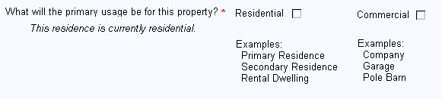

No | Primary Usage
1 | Mandatory – Choices limited to Residential or Commercial. If user attempts to move off the view Display system error message 030 in section 11.5.
2 | Residential flag needs to be disabled and Commercial flag automatically marked if the premise is currently Commercial and the Primary Flag is marked. Change from commercial to residential will not permitted.
3 | Display text “This residence is currently [residential] or [commercial].”

      - Residential Questionnaire
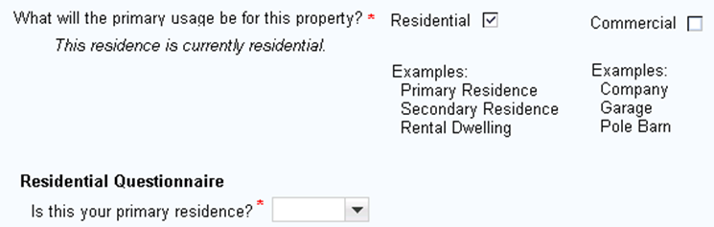

No | Residential Primary Residence
1 | Mandatory – Choices limited to Yes or No. If user attempts to move off the view Display system error message 040 in section 11.5.
2 | If the answer is ‘Yes’ then section 11.1.1.2.1 follows
3 | If the answer is ‘No’ then section 11.1.1.2.2 follows

        - Residential Primary Questionnaire

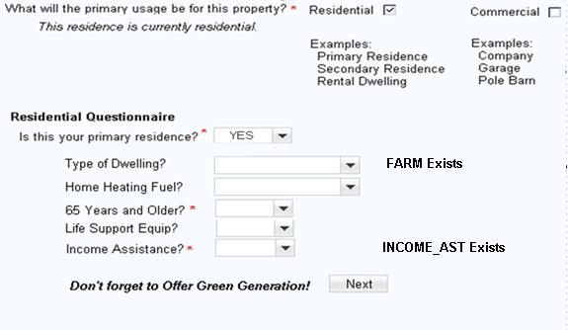

- If the user attempts to navigate using the Next button perform the following Checks”
  - If Type of Dwelling is Null, then display system error message 080 in section 11.5 and place cursor on field
  - If Home Heating Fuel is Null then display system error message 090 in section 11.5 and place cursor on field.
  - If Senior is Null then display system error message 050 in section 11.5 and place cursor on field.
  - If Life Support is Null then display system error message 100 in section 11.5 and place cursor on field.
  - If Income Assistance is Null then display system error message 060 in section 11.5 and place cursor on field.

        - Residential Secondary Questionnaire
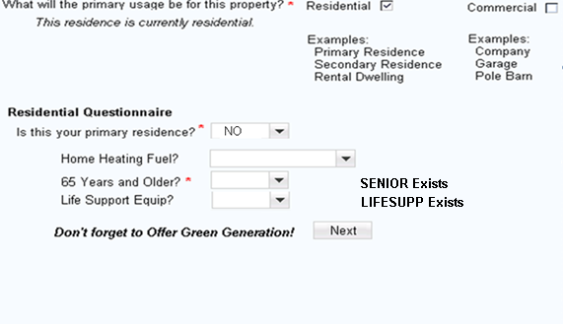

- If the user attempts to navigate using the Next button perform the following Checks”
  - If Home Heating Fuel is Null then display system error message 090 in section 11.5 and place cursor on field.
  - If Senior is Null then display system error message 050 in section 11.5 and place cursor on field.
  - If Life Support is Null then display system error message 100 in section 11.5 and place cursor on field.
.

Question |  |  | Value | Logic | Primary Residence
Type of Dwelling | Mandatory |  | FARM, Blank (default) | Display text “FARM Exists” if BP has an active Farm attribute on an active contract | YES
Home Heating Fuel | Mandatory |  | ELECTRIC, GAS (default), OTHER |  | Field Always present
65 Years or Older | Mandatory |  | YES or NO | Display text “SENIOR Exists” if BP has an active SENIOR attribute on an active contract. | Field Always present
Life Support Equip | Mandatory |  | YES or NO (default) | Display text if active LIFESUPP attribute exists on another of the BP’s active contracts. | Field Always present
Income Assistance  Statement | Mandatory | YES or NO |  | Display text if active Income Assistance attribute INCOME_ASC or INCOME_AST if the BP has other active contracts and has an active INCOME_ASC or INCOME_AST attribute.  Income assistance has to be derived from ECC  If INCOME_AST. If found Display Text INCOME_AST Exists  If INCOME_ASC. If found Display Text INCOME_ASC Exists  If both exists then display Text of “INCOME AST exists”  If neither are found and the user selects YES then display, “Refer to CSHS for qualifications” beneath the Income Assistance Question. | Yes
Hierarchy Processing Logic |  |  |  | If both Types of Dwelling and Senior is selected, the Type of Dwelling takes precedence as to what attribute is displayed on the Contract Details view. All attributes are created | Yes

      - Commercial Questionnaire

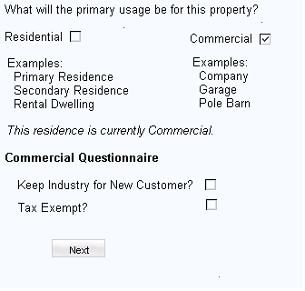

Question |  | Value | Logic
Keep Industry | Optional | Yes or No(default) | If the current billing class is residential then the ‘Keep Industry” question is disabled  If the current billing class is commercial then the ‘Keep Industry” question is enable
Tax Exempt | Optional | Yes or No(default)

How to determine the new product once the user has answered all the questions and selected the NEXT button.

Loop through all the contracts selected for the premise and perform the following:

The existing billing class can be sourced from the most recent contract's product for the POD. The product will have a new product classification call "Billing Class" (new enhancement). The New Billing class will be selected by the user via the product questionnaire.

IF the existing billing class <> the new billing class.
IF New billing class = Residential.
Old Product = “_COM2RES”
ELSE.
Old Product = “_RES2COM”.
ENDIF.
END

IF the existing billing class = the new billing class:
Get the current product for the POD.
ENDIF.

ECC FM Z_GET_NEW_MI_RATE_CAT is used to determine the product of the new contract. The following criteria will be used to determine the product:
- New Billing class
- Home Heating
- Division
- Keep Industry
- Current product of the questionnaire

How to determine the product attributes once the user has answered all the questions and selected the NEXT button. Create the following attributes based on the product questionnaire answers.

- If type of dwelling = ‘FARM’ then create the product attribute during Submit of the New Contract with the validity start date = to the new contract start date.
- If type of heating fuel = ‘Electric’ no updates will occur in CRM as a product related attribute for Heating Fuel will not exist.
- If the 65 or older = ‘Yes’ and Primary Residence = ‘Yes’: then create the product attribute SENIOR during the submit of the New Contract with the validity start date = New Contract Start Date.
- If Life Support = ‘Yes’ logic:

If primary residence = Y
If the LIFESUPP attribute exist on any contract within the last 12
months ,
- Create the product attribute LIFSUPP during the submit of the New Contract with the validity start date = New Contract Start Date
else (operand doesn’t already exist)
- Do nothing
else (primary residence = N)
Do nothing

  - Move-In Workflow - Another function of the product questionnaire is to pass information to the ECC Move-In Workflow, triggered after replication, using ECC structure ZFOCS_PMI_COS. The results of the questionnaire will need to be passed to the workflow for additional processing. Populate the structure as required”
    - ZFOCS_PMI_COS-TAX_EXEMPT = Commercial Questionnaire tax exempt indicator (X)
    - ZFOCS_PMI_COS-LIFE_SUPPORT – Residential Questionnaire Life Support indicator (X)
    - ZFOCS_PMI_COS-PRIME_TIMER – Residential Questionnaire Senior indicator (X)
    - ZFOCS_PMI_COS-PRIMARY_RESIDENCE – Residential Questionnaire Primary residence indicator (X)
    - ZFOCS_PMI_COS-DWELLING_TYPE – Residential Questionnaire Dwelling indicator (X)
    - ZFOCS_PMI_COS-HOME_HEAT_FUEL – Residential Questionnaire Fuel Type indicator (X)
    - ZFOCS_PMI_COS-BILL_CLASS – Residential/Commercial Questionnaire Billing Class indicator (X)
    - ZFOCS_PMI_COS-INCOME_ASSISTANCE – Residential Questionnaire Income Assistance indicator (X)

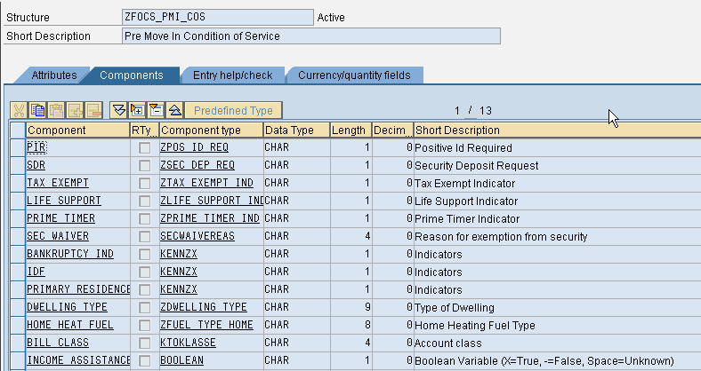

Contract & Meter Details
The Contract & Meter Data view set allows the user to view the contracts and results from the Product Questionnaire. The user will be able to edit the security deposit and connection Fee amounts and provide New Contract Meter reads. The existing view will be enhanced. Only installation divisions of Electric (01) and Gas (02) will be presented in the Contract Details view.

UI Component - IUICCON
View - IUICCON/ContractListStart

      - Contract Details

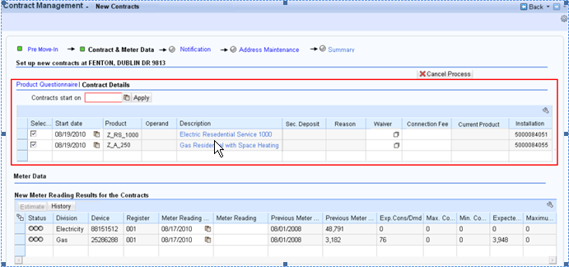

On the Contract Details View, remove the hyper links for all the fields in Contract Details (e.g., Installation, Product Description and Date). Also Start Date is display only and user should not be able to change it. The only way to change the Start date is through date applied in the Contracts start on field.

        - Cancel Process
If the user decides to cancel the process by selecting the ‘Cancel Process’ button then the standard confirmation dialog popup should be displayed. If the user confirms cancellation then the Identification View should be displayed and the user will have to restart the entire New Contract process.

If notifications have been create prior to selecting the Cancel Process button then display the follow:

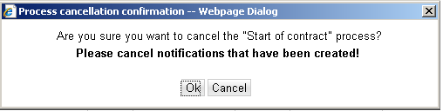

If notifications have not been created, display the following:

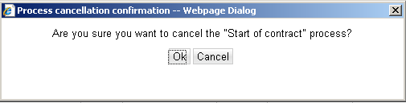
Press CANCEL. The system should remain in the current view.

Press OK. The system should navigate to the BP Identification view.

        - Contract Start Date
This field will not be defaulted to the system date. The agent will ‘Apply’ the start date of the new contacts. System error message 070 in section 11.5 until the user enters the contract start date. Once the date has been added then the Meter Data section will be displayed. Changes to the Contract Start date will result in corresponding meter read date change as well.
        - Security Deposit
The logic below is used to determine if a security deposit will be required. The security deposit amount is then presented in the Contract Details view. The user will be allowed to edit the security deposit amount, but if the user removes the security deposit amount, then the waiver reason (11.1.2.1.4) will be mandatory.
The security deposit check is only performed when FACTA validation passes or the user declined validation.
If a security deposit calculation is required, then for all POD’s get the installation number and call the ECC function module 'Z_CALC_SECURITY_DEPOSIT'.
For each installation display the security deposit amount and store the total amount to be used in the Summary View. The security deposit amount will be created during the creation of the New Contract and replicated to ECC.
The logic to determine if a security deposit should be charged is:
- "Dunning Level Reached" (Z_MI_VERIFY_PREMISE Perform GET_BP_DETAILS. If the New Contract Business Partner has any business agreements with Dunning Level (MAHNS) = 40 AND a DUNN disconnection document exists in status 21, create a security deposit. Map the reason to “Disconnect for Non-Pay”.
- “Unpaid Write-Off Balance”:
Get the business partner’s total unpaid write-off balance for all contract accounts. Look for billing documents where the clearing status is cleared and the main transaction is ‘Statistical Write off’ (6999) and the sub transaction is 0010 or the main transaction is ‘Converted Utility UA’ (8010).

If Total (for all business agreements for a given BP) >= $250, create a security deposit. Map the reason to “Owes Prior Service Account”.

- “Unpaid Final Amount Due”:
Get the business partner’s total unpaid Final Amount Due balance for all contract accounts. Look for billing documents with a main transaction of ‘Final billing (0200) or ‘Converted Final Utility’ (8005) and the clearing status is blank and has not been reversed and the due day for net payment is less than the system date.

If Total >= $250, create a security deposit. Map the reason to “Owes Prior Service Account”.

        - Security Deposit Reason
The two Security Deposit Reasons will be limited to “Owes Prior Service Account” and “Disconnect Non-Pay as described in section 11.1.2.1.2. The corresponding values will be 0001 and 0009 respectively. The text should be displayed in CRM and the numeric value passed when creating the ECC move-in document.

If the Security Deposit field is entered manually then the Security Deposit Reason is mandatory.

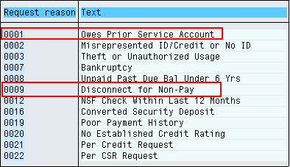

        - Waiver
The waiver field should be enabled only when a security deposit has been requested. The user may waive the security deposit by entering a reason. If the user removed the security deposit amount and does not supply the waiver reason the display. The waiver reason numeric value should be passed to ECC when creating the move-in document. System error message 110 in section 11.5.

If user removes the manually created Security Deposit then Waiver Reason is NOT mandatory.

The code saved to the contract should be the numeric value.
Code | Text
0001 | Good Credit
0002 | Low Consumption
0003 | Assistance/SPP or WPP Enroll
0004 | Company Error

        - Seasonal Customers Connect Fee
The Seasonal Connection Fee check is only performed when FACTA validation passes or the user declined validation.

If the following criteria are met then the customer is considered a seasonal customer and a Connection Fee will be posted. The user will be able to waive the connection fee by removing the amount. If the connection fee is waived or accepted, it will be written to the Interaction Record.
- If it is the same Business Partner moving into the same premise, and a customer requested disconnection doc exists, and disconnect date is within 1 year, then the customer is considered as a seasonal customer.
- FACTA ID check did not fail
If it is determined that a Seasonal Connection Fee is required, then call ECC function module FKK_CALC_CHARGE with R2 as the Charge ID and Charge Type.

The connection fee dollar amount will be displayed in the Contract Details view and the user will be able to edit or remove the amount. The amount will be passed to the ECC Move-in workflow for subsequent processing.

  - Move-In Workflow - Another function of the product questionnaire is to pass information to the ECC Move-In Workflow, triggered after replication, using ECC structure ZFOCS_PMI_COS and table ZFOCS_INSTALL_OPTION_T. The results of the questionnaire will need to be passed to the workflow. Populate the structure as required
    - ZFOCS_PMI_COS-SDR – Mark with X if a security deposit is requested and not waived in the Contract Details View
    - ZFOCS_INSTALL_OPTION_T-ANLAGE – Table entry of the Installation associated with the New Contract item
    - ZFOCS_INSTALL_OPTION_T-SPARTE – Table entry of the division of the contract
    - ZFOCS_INSTALL_OPTION_T-CONN_FEE - Table entry of the Connection Fee associated with the New Contract item
    - ZFOCS_INSTALL_OPTION_T-SEC_DEPOSIT - Table entry of the Security Deposit associated with the New Contract item

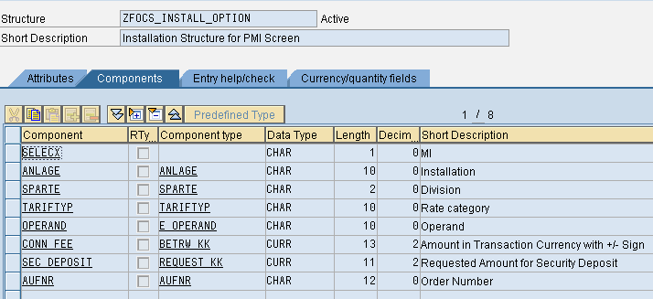

      - Meter Reading
The agent will use the Meter Data view to enter, estimate, release, meter readings of reason 06. The user should be able to display all meter read history for all devices via the existing functionality. The existing view will be enhanced. It will be possible that an installation will not have a meter and will not be displayed.

UI Component – IUICMRD
View - IUICMRD/MeterReading

In the scenario where a force end contract will be created, the meter readings entered for the new contract will be applied to the force ended contract as well.

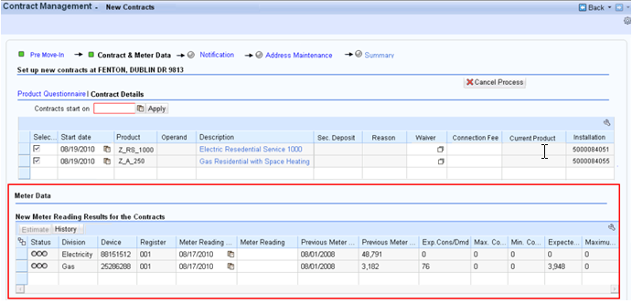
The Meter Data View
            - Meter Read Date – The meter reading date should change to equal the Contract Start Date. User should not be able to change the Meter Read Date. It should always be equal to the Contract Start date applied.
            - Meter Read Validation – No change to standard SAP validation
            - Meter Read Estimation – No Change to standard SAP estimation
            - Meter Read Release - REMOVE the ‘Release’ button from the Meter Data View.
            - Meter Read History – No Change to the standard SAP.

UI Design and Screen Flow
< Mention the WEBUI Design in the sense the mock up screens and the navigation flow between the screens etc>

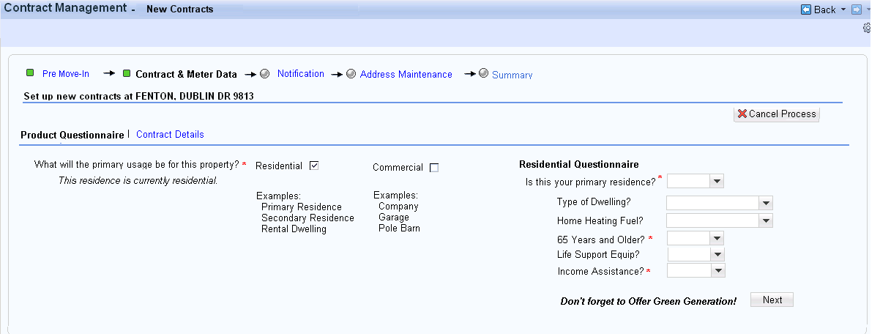
Figure 11.2.1

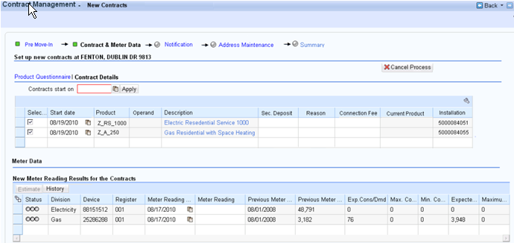
Figure 11.2.2

Access Method or Path for Enhancement
<Select the correct execution path below by placing an ‘X’ in the checkbox next to it and completing the description that follows. Check all that apply and add any other execution methods if required by the Client. Right click on the gray box, select properties, and specify “Checked”.>
Execution: Custom Transaction Code:
Menu Path:
Standard Transaction Code:
Other: CRM 7.0 Web IC Navigation

Required Custom Tables (if known)
<Provide any information about custom tables required for this enhancement.>
N/A
Table Name: Enter Table Name
Table Description: Enter Table Description
M/O | Field Description | Type (text or numeric) | Maximum Field Length | Value Restrictions? | Validations?
Mention M if the field is mandatory and O if the field is optional | Enter the field description | Enter the type | Enter the max. field length | Enter any value restrictions | Mention if any validations are required or else mention NA

Error Handling Rules
<Explain what the error handling rules would be if there are any for this development. For example, if an enhancement is scheduled to be printed and it does not, what should a user do to get this corrected?>

Msg No | MSG TYPE | CRM 7.0 System Messages to Appear on Product Questionnaire View
010 | Warning | Multi Dwelling Determination - A warning message will be created if a Multi-Dwelling Rate has been identified on any installation in which the customer is moving into.  Message: Multi Family Dwelling Automated Rate Category Update Not Allowed | These rate categories are sourced from table ZTFO_RATECATCAT for category = MULTDWELL
020 | Warning | TOD and TOU Alert – A warning message will be created if the product for the current time slice is RT_1010 or RT_2010.  Message: TOD Automated Rate Category Update Not Allowed | These rate categories are sourced from table ZTFO_RATECATCAT for category = TOU
030 | Error | Message: Please indicate whether this is residential or commercial
040 | Error | Message: Please indicate whether this is a primary residence
050 | Error | Message: Please indicate whether the business partner is 65 years or older.
060 | Error | Message: Please indicate whether the business partner needs income assistance
070 | Error | Message: Apply Contract Start Date
080 | Error | Message: Please indicate the Type of Dwelling
090 | Error | Message: Please indicate the Type of Fuel
100 | Error | Message: Please indicate Life Support required
110 | Error | Message: Please supply security deposit Waiver Reason

Enhancement Reconciliation & Testing Requirements

Data Validation
Data validation will require the expected test cases execution and verifying the results based on business requirements. CRM project team along with their business support teams will be responsible to ensure this enhancement works.

Testing Reconciliation
This enhancement will be tested by the teams (their security roles) who perform the New Contract process. Teams will include CRM project team, BTS support team, Call Center, BCOS, Revenue Recovery, Consumer Affairs, and Billing.

Performance Issues
N/A

Additional Information
<Enter any additional information that could be helpful in developing this enhancement.>
N/A

Open Items
<This includes Risks and Issues logged in Clarity and Action Items.>
Item # | Detailed Description | Proposed Solution
Insert number | Describe the item | Describe the proposed resolution

Functional Unit Test cases <Here they should list the possible test scenarios in the table below>
Test Condition Description | Input Data | Expected Results | Actual Results/Comments
User attempts to move off product questionnaire without entering usage type |  | Error Message “Please indicate whether this is residential or commercial “ is displayed
User attempts to move off product questionnaire without entering resident status |  | Error Message “Please indicate whether this is a primary residence “ is displayed
User attempts to move off product questionnaire without entering Senior question |  | Error Message “Please indicate whether the business partner is 65 years or older. “ is displayed
User attempts to move off product questionnaire without answering income assistance question |  | Error Message “Please indicate whether the business partner needs income assistance “ is displayed
User attempts to move off product questionnaire without answering the type of dwelling question |  | Error Message “Please indicate the Type of Dwelling “ is displayed
User attempts to move off product questionnaire without answering the type of fuel question |  | Error Message “Please indicate the Type of Fuel “ is displayed
User attempts to move off product questionnaire without answering the life support question |  | Error Message “Please indicate Life Support required “ is displayed
Premise is currently Commercial.  Tax Exempt is selected  Keep the Same Industry selected  Security deposit requested due to Disconnect Non-Pay  Low Meter readings entered  User attempts to move off the Contract & Meter Data view without ‘Applying’ the contract start date |  | Residential check box is disabled and Commercial check box is marked.  Keep the Same Industry is used to derive product. Product is displayed  Security deposit amount displayed  (Request reason is displayed on the ECC move-in document)  Error Message “Apply Contract Start Date “ is displayed
Premise is currently Commercial.  Tax Exempt is not selected  Keep the Same Industry is not selected  User applies Contract Start Date  Security deposit requested due to Disconnect Non-Pay is waived with reason  Company Error  No Meter readings entered |  | Residential check box is disabled and Commercial check box is marked.  Keep the Same Industry is used to derive product. Product is displayed  Security deposit amount is removed and waiver reason of Company Error is displayed.
Premise is currently Commercial.  Tax Exempt is not selected  Keep the Same Industry is not selected  User applies Contract Start Date  Security deposit requested due to Disconnect Non-Pay is waived with reason  Company Error  User enters security deposit amount  No Meter readings entered |  | Residential check box is disabled and Commercial check box is marked.  Keep the Same Industry is used to derive product. Product is displayed  Security deposit amount is displayed and waiver reason removed.
Premise is currently Residential.  User selects Commercial usage  Tax Exempt is selected  Keep the Same Industry is not selected  User applies Contract Start Date  No security deposit is calculated.  No Meter readings entered |  | Default product is selected. Product is displayed
Premise is currently Mulit Dwelling Residential  User selects Residential usage  Primary status is selected  Type of Dwelling = Null  Home Heating Fuel = Electric  65 Years of Older = No  Life Support Equip = No  Income Assistance Statement  User applies Contract Start Date  High Meter readings entered |  | Warning Message “Multi Family Dwelling Automated Rate Category Update Not Allowed “ is displayed  No existing product attributes are displayed.  Product source from the latest POD is displayed.  Implausible read displayed and released.
Premise is currently TOU/TOD Dwelling Residential  User selects Residential usage  Primary status is selected  Type of Dwelling = Null  Home Heating Fuel = Electric  65 Years of Older = No  Life Support Equip = No  Income Assistance Statement  User applies Contract Start Date  High Meter readings entered |  | Warning Message “TOD Automated Rate Category Update Not Allowed “ is displayed  No existing product attributes are displayed.  Product source from the latest POD is displayed.  Implausible read displayed and released.
Premise is currently Residential  FACTA FAILED  User selects Residential usage  Primary status is selected  Type of Dwelling = FARM  Home Heating Fuel = Electric  65 Years of Older = No  Life Support Equip = No  Income Assistance Statement  Security deposit due to Disconnect Non-Pay .  User applies Contract Start Date  Low Meter readings entered |  | FARM attribute is assigned to the product. The product is displayed.  Implausible read displayed and released.  Security deposit requested due to Disconnect Non-Pay is suppressed due to FACTA Failure.
Premise is currently Residential  FACTA FAILED  User selects Residential usage  Primary status is selected  Type of Dwelling = FARM  Home Heating Fuel = Electric  65 Years of Older = Yes  Life Support Equip = No  Income Assistance Statement  Seasonal Customer  User applies Contract Start Date  No Meter readings entered |  | FARM and SENIOR attributes are assigned to the product. The product is displayed.  Implausible read displayed and released.  Seasonal Connection Fee suppressed due to FACTA Failure
Premise is currently Residential  FACTA PASSED  User selects Residential usage  Primary status is selected  Type of Dwelling = FARM  Home Heating Fuel = Electric  65 Years of Older = Yes  Life Support Equip = No  Income Assistance Statement  Seasonal Customer  .  User applies Contract Start Date  No Meter readings entered |  | FARM and SENIOR attributes are assigned to the product. The product is displayed.  Implausible read displayed and released.  Connection Fee displayed
Premise is currently Residential  FACTA PASSED  User selects Residential usage  Primary status is selected  Type of Dwelling = FARM  Home Heating Fuel = Electric  65 Years of Older = Yes  Life Support Equip = No  Income Assistance Statement  Seasonal Customer  User applies Contract Start Date  No Meter readings entered |  | FARM and SENIOR attributes are assigned to the product. The product is displayed.  Implausible read displayed and released.  Connection Fee removed
Premise is currently Residential  FACTA PASSED  User selects Residential usage  Primary status is selected  Type of Dwelling = FARM  Home Heating Fuel = Electric  65 Years of Older = Yes  Life Support Equip = No  Income Assistance Statement  Security deposit due to unpaid final balance  Seasonal Customer  User applies Contract Start Date  No Meter readings entered |  | FARM and SENIOR attributes are assigned to the product. The product is displayed.  Implausible read displayed and released.  Connection Fee displayed  Security deposit displayed and mapped to “Owes Prior Service’
Premise is currently Residential  FACTA PASSED  User selects Residential usage  Primary status is selected  Type of Dwelling = FARM  Home Heating Fuel = Electric  65 Years of Older = Yes  Life Support Equip = No  Income Assistance Statement  Security deposit due to unpaid write-off balance  User applies Contract Start Date  No Meter readings entered |  | FARM and SENIOR attributes are assigned to the product. The product is displayed.  Implausible read displayed and released.  Security deposit displayed and mapped to “Owes Prior Service’
Premise is currently Residential  FACTA PASSED  User selects Residential usage  Primary status is selected  BP has existing service with a FARM product attribute  BP has existing service with a SERNIOR product attribute  BP has existing service with a Life Support product attribute  BP has existing service with a Income assistance (Gas and Electric) product attribute  Type of Dwelling = Null  Home Heating Fuel = Electric  65 Years of Older = Yes  Life Support Equip = No  Income Assistance Statement  Security deposit due to unpaid write-off balance  User applies Contract Start Date  Estimate Meter readings entered |  | Product Questionnaire text are displayed:  “Farm Exists”  “Senior Exists”  “Life Support Exists”  “INCOME_ASC Exists”  SENIOR attributes are assigned to the product. The product is displayed.  Implausible read displayed and released.  Security deposit displayed and mapped to “Owes Prior Service’  Meter Readings estimated
Premise is currently Residential  FACTA PASSED  User selects Residential usage  Primary status is selected  BP has existing service with a Income assistance (Gas) product attribute  Type of Dwelling = Null  Home Heating Fuel = Electric  65 Years of Older = Yes  Life Support Equip = No  Income Assistance Statement  Security deposit due to unpaid write-off balance  User applies Contract Start Date  No Meter readings entered  Display Meter Reading History |  | Product Questionnaire text are displayed:  “Life Support Exists”  “INCOME_AST Exists”  SENIOR attributes are assigned to the product. The product is displayed.  Implausible read displayed and released.  Security deposit displayed and mapped to “Owes Prior Service’  Meter Reading history displayed

